**STEP 1**

Install ABAP Development Tools (ADT)

1. Open the <https://www.eclipse.org/downloads/> to download the corresponding Eclipse version.

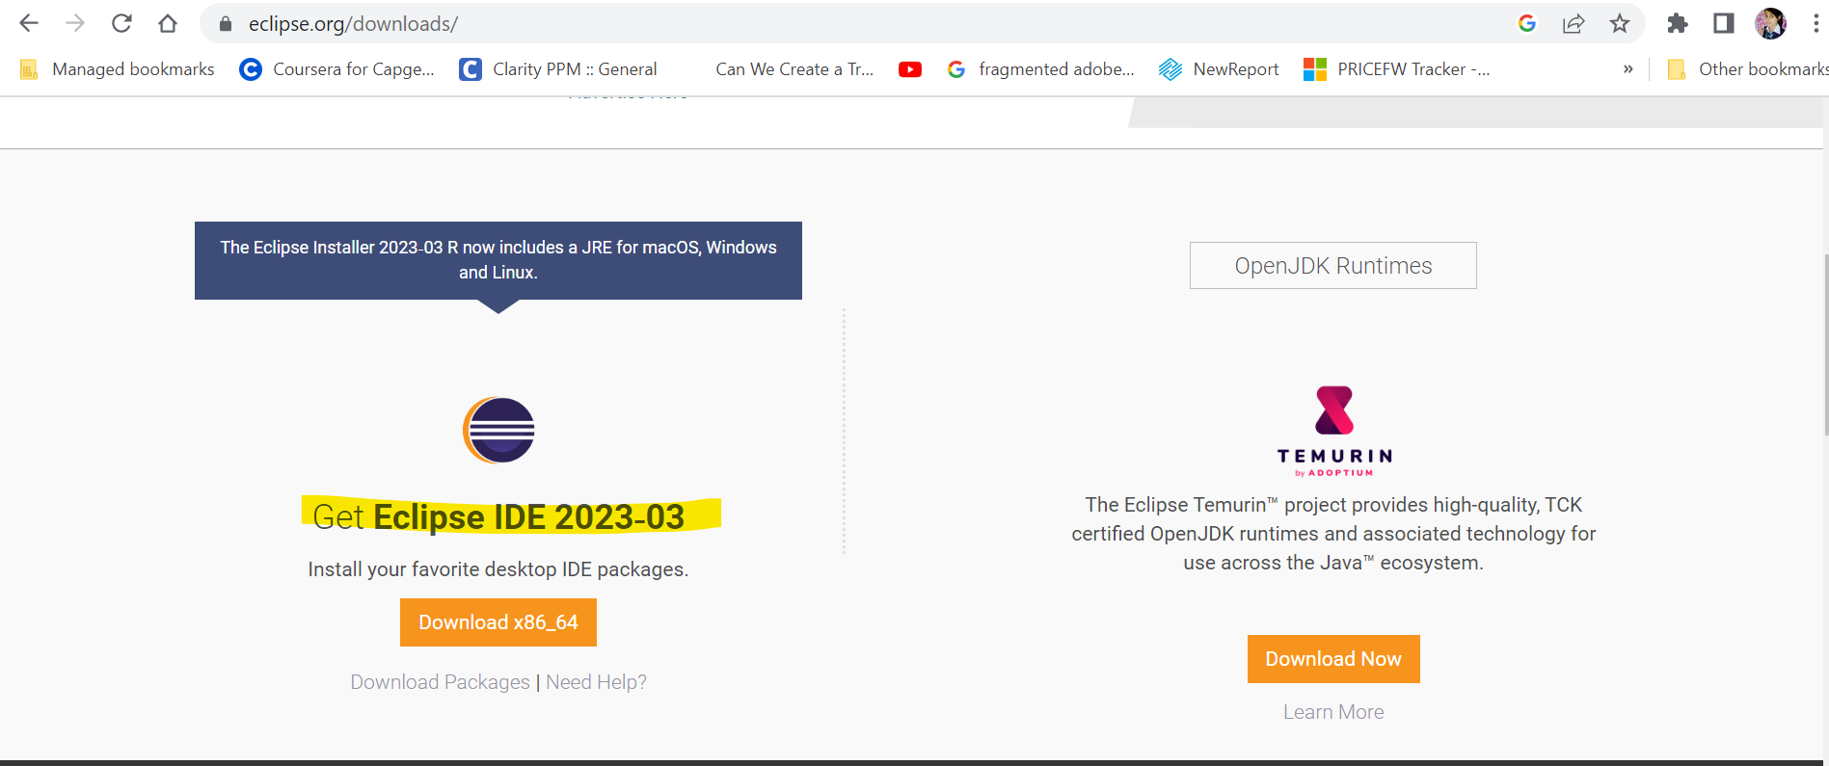

1. Click Download.

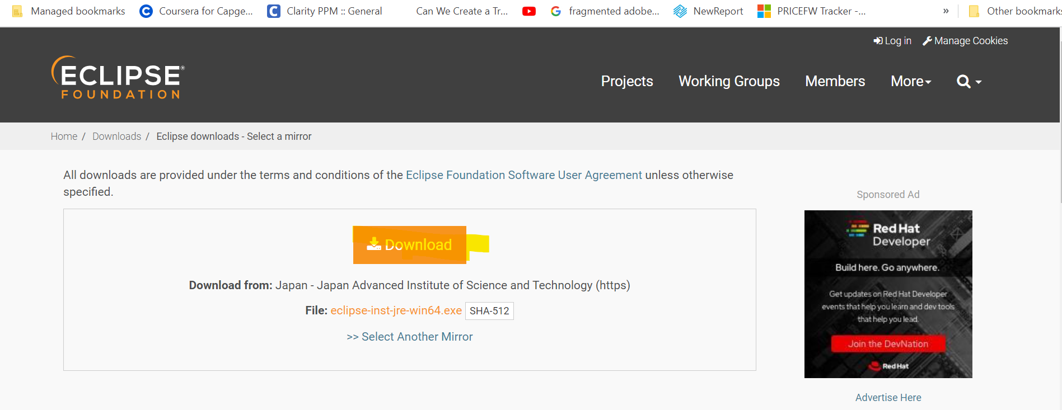

1. Download the software & install it.
2. While installing provide, choose eclipse installer as RCP& RAP dev.

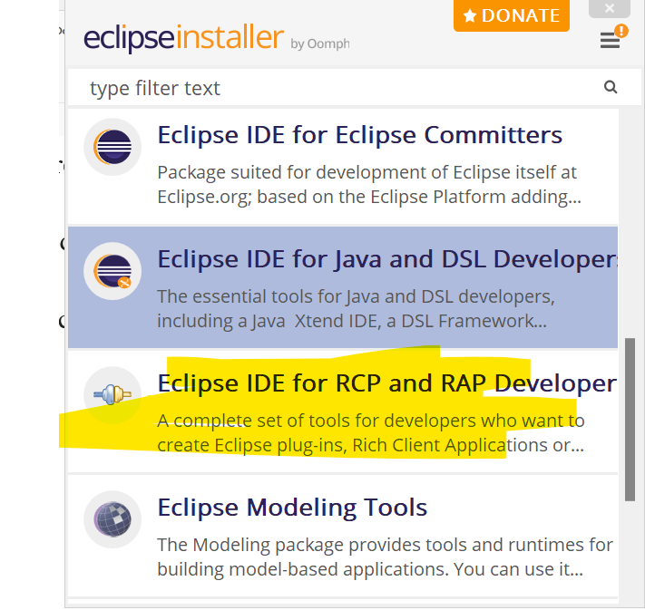

1. Launch your workspace.

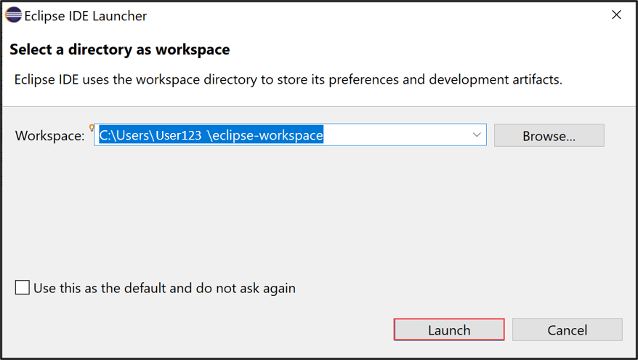

1. Close both pages.

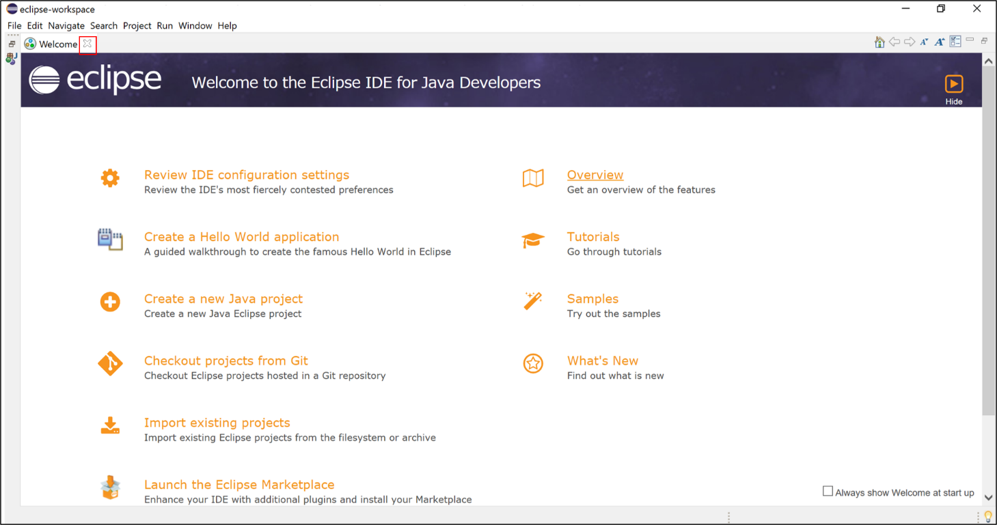

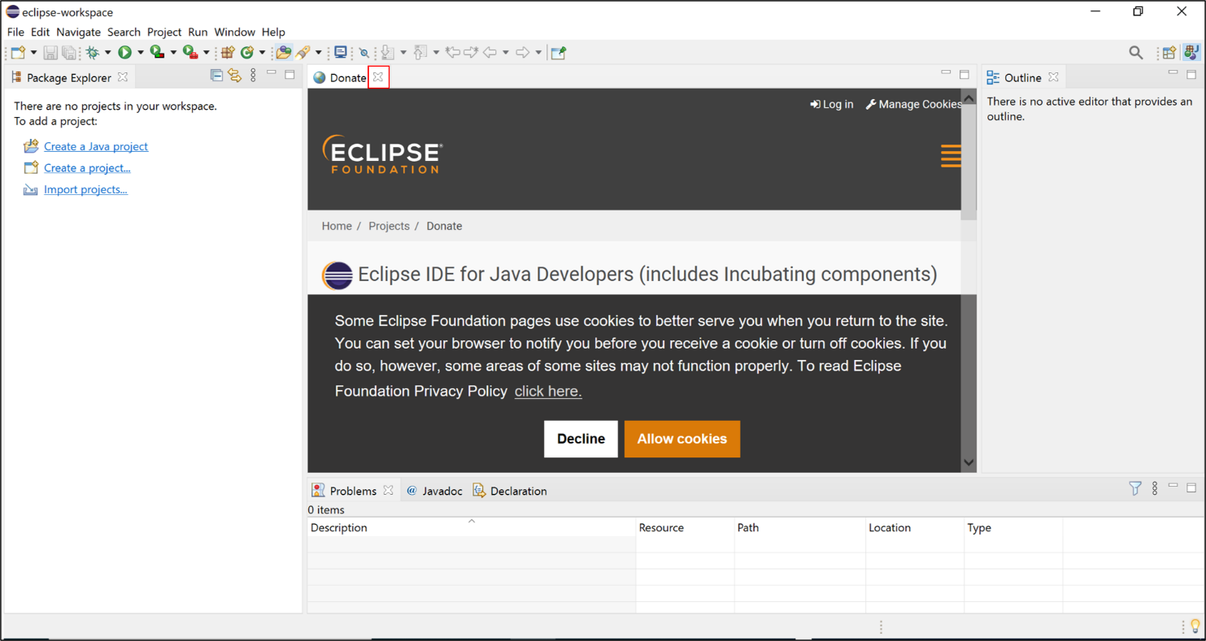

1. Select Help > Install New Software.

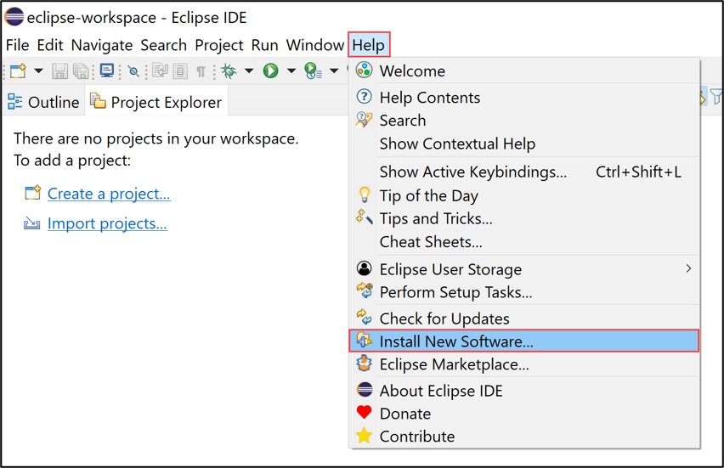

1. Enter the latest ADT URL https://tools.hana.ondemand.com/latest in the Work with section, press enter, select all check box and click Next >.

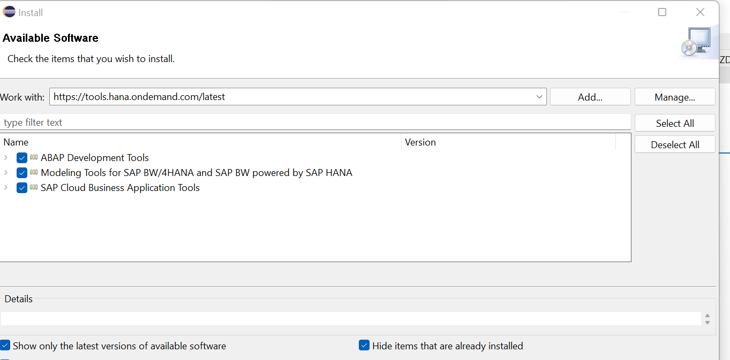

1. Click Next >.

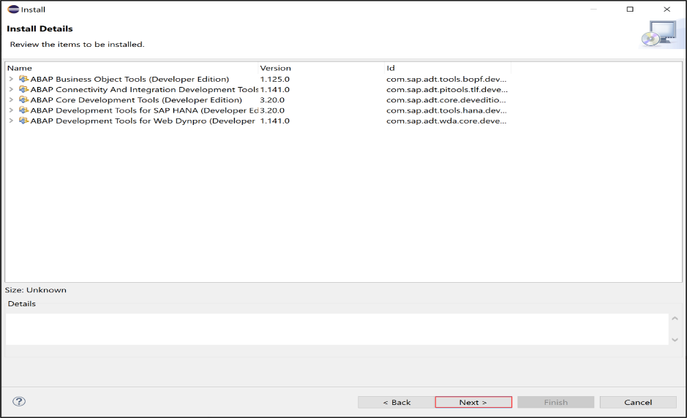

1. Accept the license agreement and click Finish.

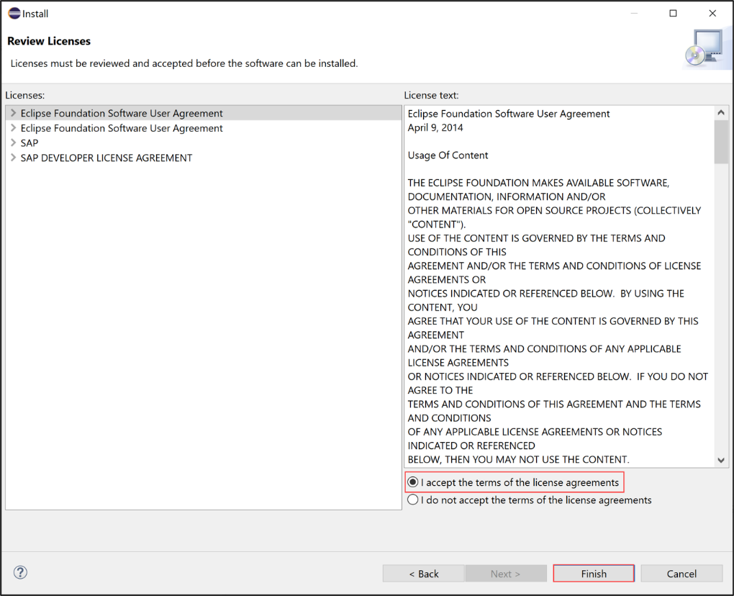

1. Now ADT will be installed. Select Install anyway.

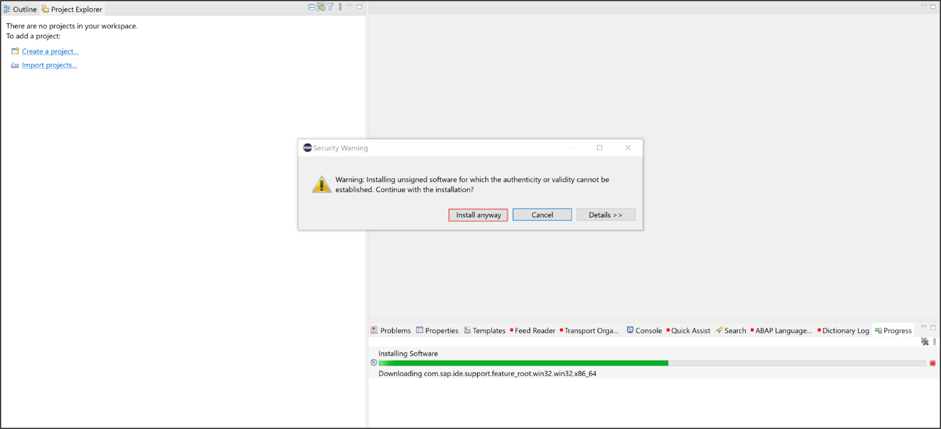

1. Click Select All and Accept selected.

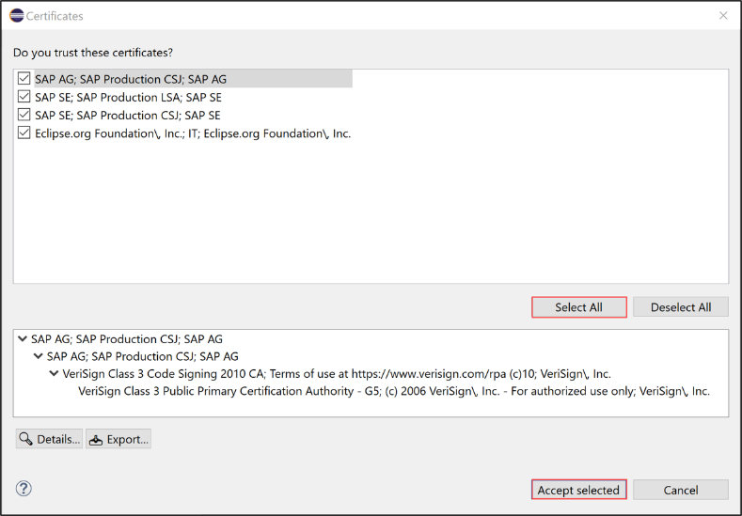

1. Click Restart Now.

